\*Get me the IP address of a particular domain (guvi.in). How do I find my CPU/memory usage of my server. Test the connectivity between 2 nodes?

Ans: To find the Ip address for the particular domine need to use ping cmd or Host cmd or dig cmd

I have use the Ping cmd and host cmd for the domine called www.amazon.com and the result is below

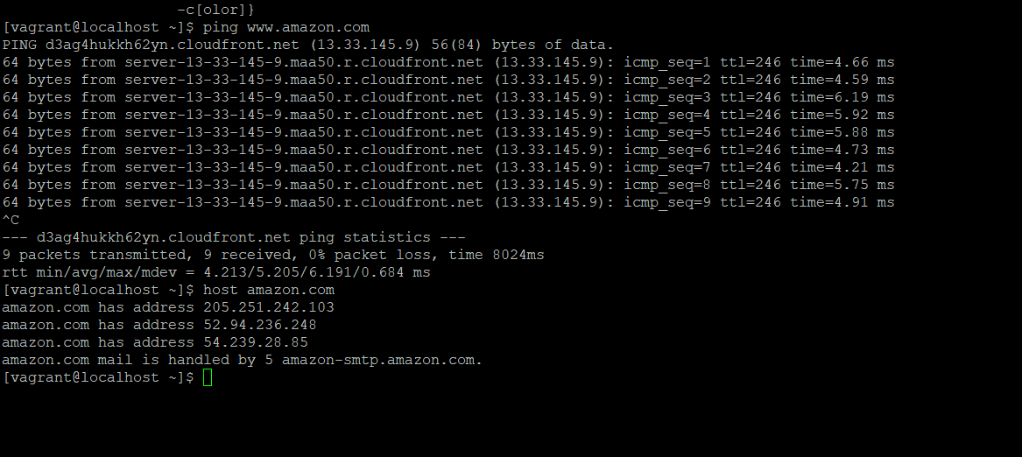

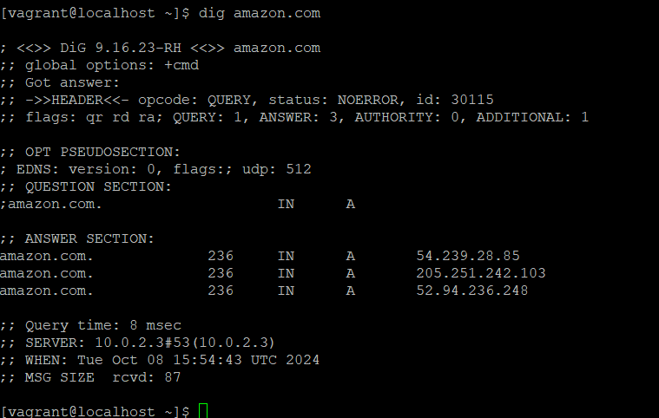

to find the CPU usage we need to use top cmd or htop

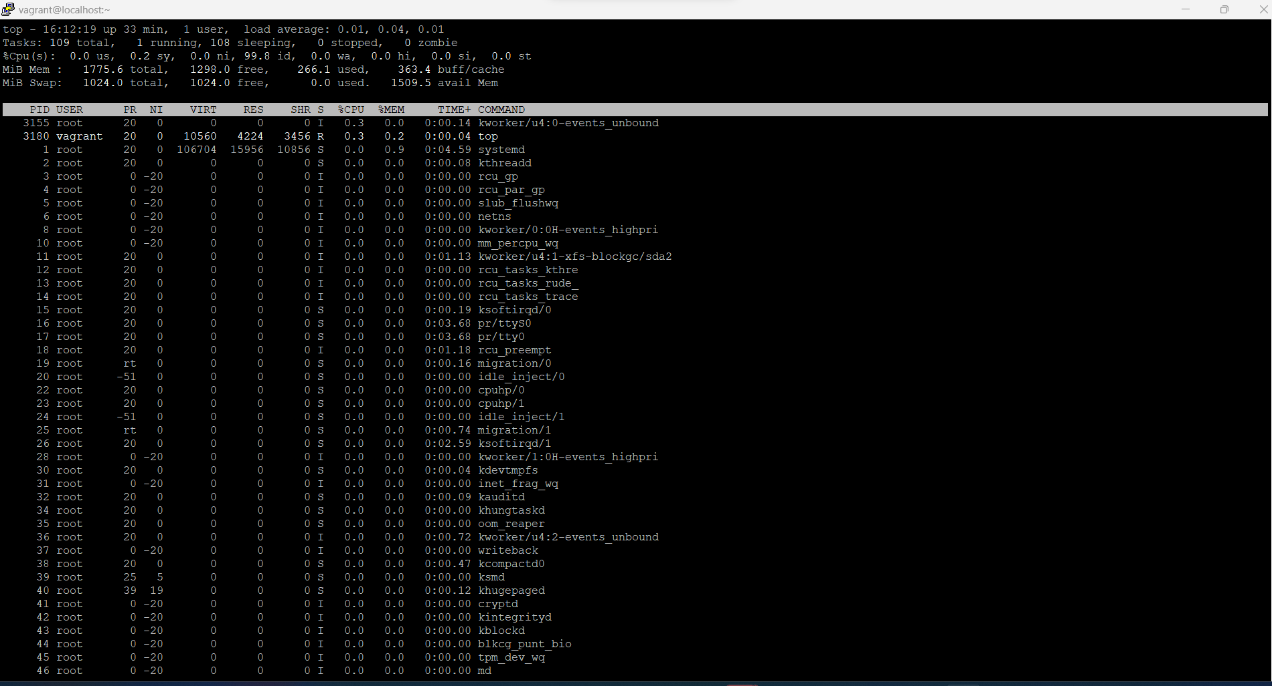

We can use the cmd called netsat -tunpl to check the port or we can use the telnet cmd

